**PLAYROOM ACTIVITIES:**

* Elephant friend for cubetto
* Cubetto crafts (Wooden sledge for cubetto; Make a dog mask; create a camp site for cubetto; Ghostly costume)
* Circle Time; Square Time; Snake; Santa hat and gift sack; make cubetto a spooky spider; baseball cap; Build a house; Skyline for a city adventure; obstacle course with cubetto; adventure backpack for cubetto; construct a forest; navigate a maze;

**Maze Activities:**

* 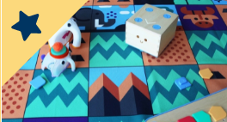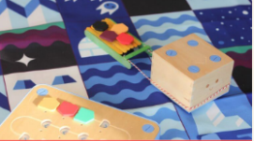Winter wander; Color quest

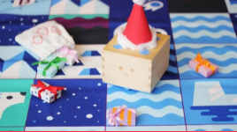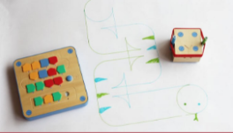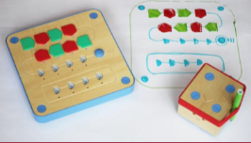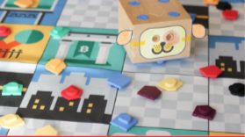

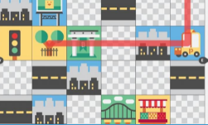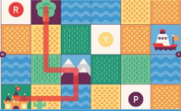

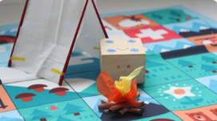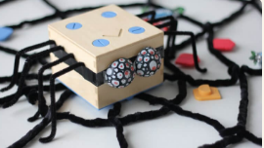

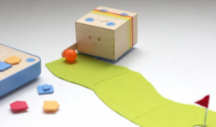

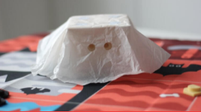

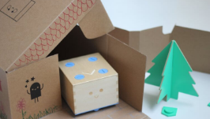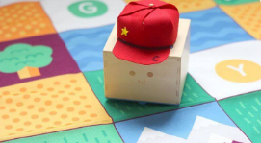

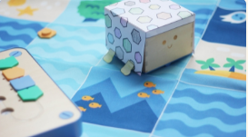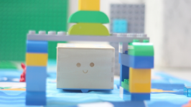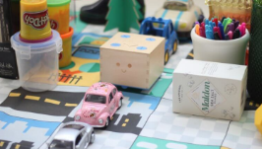

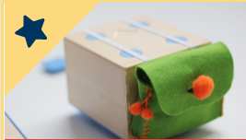

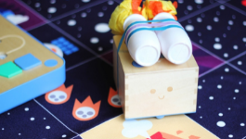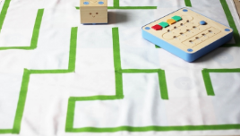

**LINK:**

https://youtu.be/4Az0uXB0plk

**Story books:**

* Book 0 (Instruction guide)
* Book 1 (First day of cubetto)-World map play-set
* Book 2 (cubetto gets lost)-Big city story book
* Book 3 (Cubetto class trip)-Ancient Egypt storybook
* Book 4 (Cubetto’s Deep drive)-Blue ocean story book
* Book 5 (Cubetto’s leaves earth)-Deep space storybook
* Book 6 (Cubetto Snowy sled race)-Polar expedition storybook
* Book 7 (Cubetto in the swinking swamp)-swampy swamp
* Book 8 (Cubetto on safari)-Savannah storybook

**MAPS:**

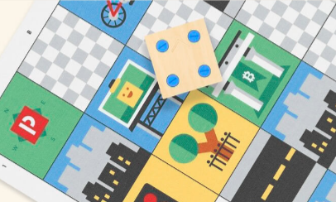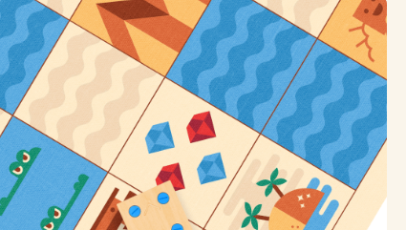**Ancient Egypt: Big city**

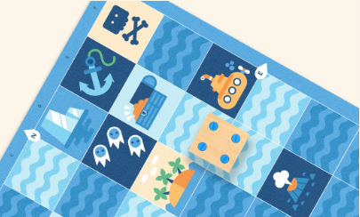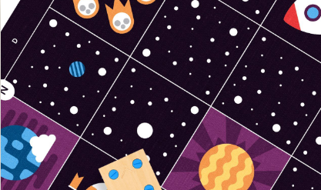**Blue Ocean Deep space**

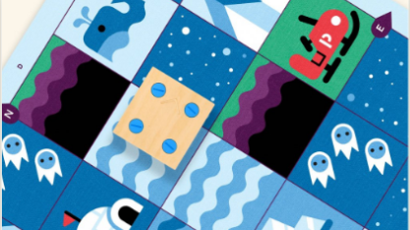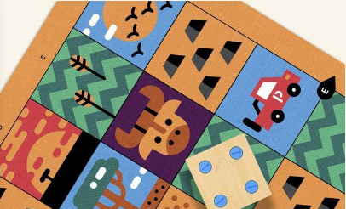**Polar expedition Savannah (Safari)**

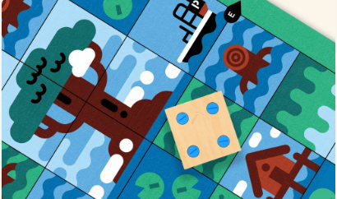 **swampy swamp**